Ex no:2b VM-VM ping, VM-Native Ping
Date:20-07-2026

Aim:
To check the victim or target is alive between vm -vm and vm-native using the ping command .
Steps: Before ping commands
- Both VMs are Powered ON
- Both are connected to the same network (e.g., Host-Only or Bridged)
- Each VM has a valid IP address (like 192.168.56.x)
- Firewall is disabled or ICMP is allowed
Find IP Addresses
  - Using ip a or ifconfig in VM
  - Using ipconfig in windows
To enable VM-to-VM and VM-to-host ping communication in VirtualBox, first set both VMs' network adapters to "Host-Only Adapter" (e.g., vboxnet0) via VirtualBox → Settings → Network. Then, start both VMs and run ip a inside each to find their IP addresses (usually 192.168.56.x). On each VM, disable the firewall using sudo ufw disable and optionally flush iptables with sudo iptables -F. On the Windows host, enable ICMP ping by opening "Windows Defender Firewall with Advanced Security", going to Inbound Rules, and enabling "File and Printer Sharing (Echo Request - ICMPv4-In)". Now, use ping <other_VM_IP> from one VM to the other, and from the host, use Command Prompt to ping each VM’s IP (e.g., ping 192.168.56.101)
1)VM – NATIVE:
To check the target is alive between the host and vm using ping commands
IP address of windows:
Ip address of linux was 127.0.0.1
Using ping checking the vm is alive or not (ping 127.0.0.1)

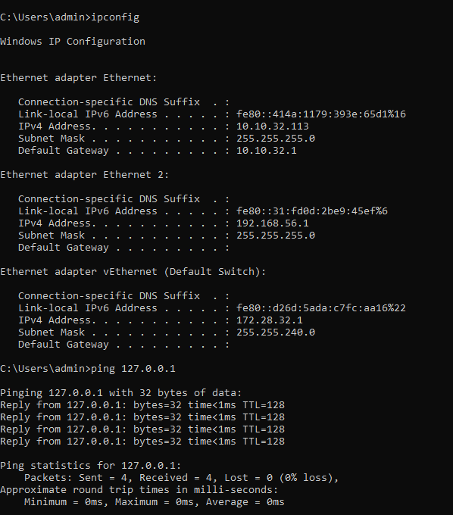
Ping for windows:
Using ping checking the host is alive or not (ping 127.0.0.1)
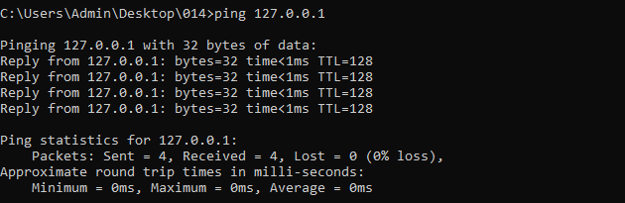
VM- VM
I am using linux (one was ubunttu) and another was (Kali linux )
Ping in Linux ubunttu:
Using ping 192.168.56.103 (Checking the kali linux is alive or not using ping in ubunttu)

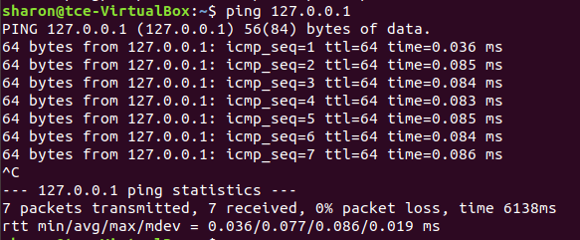4
Using ping 192.168.56.101 (Checking the ubunttulinux is alive or not using ping in kali linux)

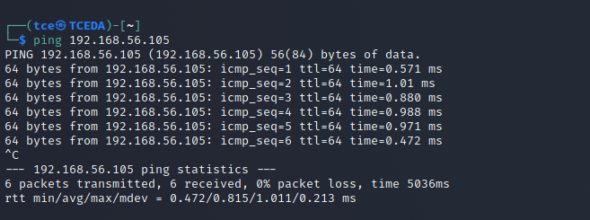

Result:
Thus the checking the victim or target is alive between vm -vm and vm-native using the ping command has been executed successfully and output has been verified.

